Day 1 Monday 3rd, 2008
08:30 Welcome Coffee

09:00 Introduction by:
Executive Managing Director & Founder of
SAMENA Telecommunications Council
Mr. Thomas Wilson
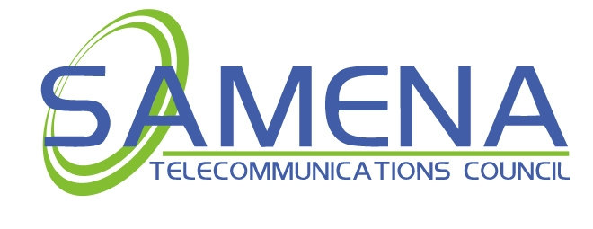
09:10 Welcome Address presented by the
Chairman of SAMENA Telecommunications
Council – OMANTEL CEO
Dr. Mohammad Al Wohaibi

09:25 Guest of Honor His Excellency
The Minister of Information and
Communications technology in Jordan–
Eng. Bassem Rousan
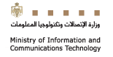

09:40 Welcome Address by Head of Entity of
The Telecommunications Regulatory
Commission in Jordan (TRC) –
H.E. Dr. Ahmad Hiasat

09:55 Opening Session Note by Diamond Sponsor
Jordan Telecom Group – Orange –
Mr. Mickael Ghossein

10:15 Key Note Speaker by Chairman of ETISALAT
Mr. Mohammad Hassan Omran


10:30 Special Invite – ITU General Director –
Mr. Hamadoun Toure


10:45 Honorary Guest Speech by U.S. Federal
Communications Commission –
FCC Commissioner
Mr. Robert Mcdowel


11:00 Coffee Break

Session 1
11:15 CEO LIVE SESSION

The CEO Live Session Panel is a “live” unscripted format by which the CEO’s will interact with the moderator and the audience in a manner that allows for a better understanding of their thoughts and mindsets toward their leadership of the leading Operators in the region, in a new and interesting format. At the end of the Moderator’s question and answer program, there may be time allowed for questions from the audience to the CEO’s. The Moderator will facilitate the questions from the audience.

12:45 Lunch Break (Sponsored by )

Session 2
14:00 Regulatory Session
Regulatory Planning and Compliance
Management
- SAMENA Regulatory Committee Public Report
  - Market Liberalization and its effect on Competition and the Consumer
  - Convergence and the Development of FMC
  - WiMAX Compliance
  - Mobile TV Curriculum and Inter-operability
- Regulator Point of View – What are the Regulator’s planning
- Mobile TV – Spectrum Management and Planning Issues – “Where is the Capacity”
- Technology Neutral Licenses – How will they Affect the Industry
- Cost of Compliance – What’s the Bottom Line
- Equal Access – Ideas on how to Apply

15:15 Coffee Break

Session 3
15:30 Broadband Wireless Access
Evolution of Technology
1. WiMAX
- WiMAX in progress and untapped business opportunities
- Pending concerns over WiMAX Deployment
- How to get WiMAX right: operators’ perspectives on trials and tribulations
- The viability of WiMAX as a WLL technology
- Assessing WiMAX’s long-term investment viability
- WiMAX and alternative technologies: a comparison
- Case studies – “WiMAX at work in the real world”
- High speed multicast video and WiMAX

2. LTE: Benefits & Impacts
- What kind of end user benefits are expected of LTE?
- How will users benefit by the interaction between LTE and other systems?
- Identifying the key players in the market around the world. Where does LTE fit amongst all the mobile networks?
- Understanding best ways of spectrum utilization, leveraging the flexible carrier bandwidth in paired and un-paired spectrum in order to gain highest performance and capacity.
- The LTE technology—Is it really 4G or 3G? Or both?
- What makes LTE the best choice for next generation mobile broadband? What is the vision for mobile broadband?
- LTE: examining standards, developments, and deployment challenges
- Spectrum challenges with LTE
- LTE versus UMB: Where does the threat lie?
- Can non-3G operators think LTE?

3. Business Modeling – Operator Revenue Planning
- Competitive analysis of existing and emerging technologies
- Applied business modeling for key technologies
- New business intelligence focus areas
- The rising tide for managed services and revenue sharing
- Growth Forecasts for STS Applications in the Smart City Environment

19:00 – 12:00 am
GALA DINNER AND AWARDS CEREMONY


Day 2 Thursday 4th, 2008
Day 1 Monday 3rd, 2008
Day 1 Monday 3rd, 2008
8:30 Welcome Coffee

Session 1
9:00 Leaders Visions

The huge impact of privatization and deregulation is also heavily impacting our business environment in the SAMENA region. These cosmic changes are literally creating upheaval and changes in habits of employees, investment and other factors that have never been known before in this region. The players are moving and changing. The rules by which the operators managed their operations have all changed. The days of the non-competitive arena are now gone forever. Competition is being introduced at a speed never seen nor understood before in the SAMENA region and the operators have to handle all of these issues all at the same time.

The Leaders of today’s service providers and operators are faced with absolutely awesome challenges that are figuratively effecting how people live and work today as well as how they perform and transact business in today’s society. The Operator Leaders are the movers and shakers of our society today. Their investment base is demanding return on equity, whilst the users are concurrently demanding the best and most feature rich services, as well as reliability that are extremely expensive to incorporate into large and expansive networks. The quandary exists, how to make this all happen at the same time. Indeed, a tough task.

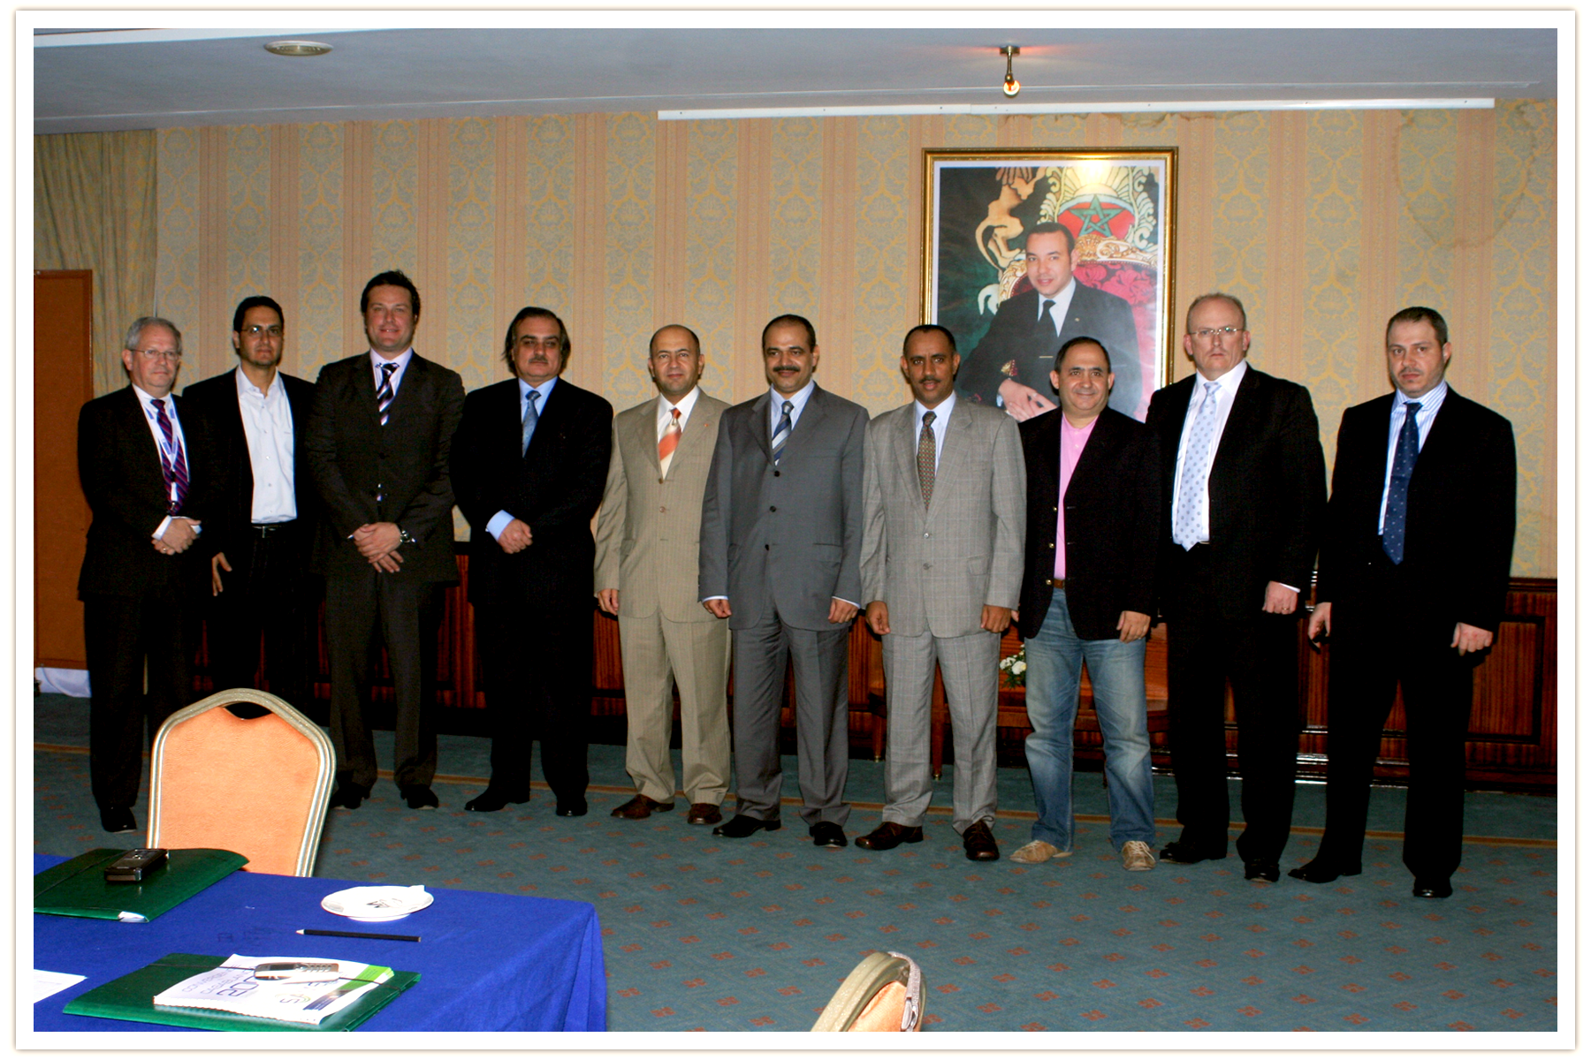

Session 2
10:30 Mobile TV Technology

- SAMENA Technology Committee Public discussion
- Maximizing Mobile TV revenues
- Market factors for mobile multimedia
- Technical challenges in standardization, interoperability, and network planning
- Reality of the Mobile TV market in the SA-ME-NA region
- Unicast versus Multicast – What are the differences in costs, application, integration and support
- Technology Neutral Licensing and the future of its application in the Regulatory Sphere
- Handsets – The majors discuss the future development of Handsets for Mobile TV
- Definition of Mobile TV Technologies and Multicasting and its benefits – offering Economy and Scalability
- Point to Multipoint Service Broadcast Technologies – Layering Current GPRS, WCDMA, HSDPA, CDMA 1X and EV-DO Networks with the following Broadcast Technology Platforms:

- Terrestrial (T-DMB (Terrestrial – Digital Multimedia Broadcasting), Media FLO (Media Forward Link Only and DVB-H (Digital Video Broadcast to the Handset) – These use UHF & VHF Frequency Bands
- Satellite/Terrestrial (DVB-SH. StiMi and S-DMB use the S-Band in the range of 2.1 & 2.6 GHz.

11:45 Coffee Break

Session 3
12:00 Security: Lawful Interception (LI)

- Lawful interception and data retention in networks
- Challenges and solutions in LI in complex digital networks
- Security compliance for multi-country service providers in the evolving world of telecom
- Cost effective intercept solution for Ethernet, IP and MPLS networks
13:00 Lunch Break

Session 4
14:00 Merge & Acquisition –
Insights for the Investor

- What will be the dominant trend in the acquisition of global telecoms assets over the next 12 months?
- What is driving the boom in M&A?
- Which part of the global telecoms value chain will see most activity and where will the best deals take place?
- When will emerging markets start snatching acquisitions in the developed world?
- How will such M&A activity consolidate assets in the region?
- Market capitalization resources, what are the values add components?
- Who will be left standing?

15:15 Coffee Break

Session 5
15:30 Fiber Optic Technology

- Fiber-Optic, GPON and XWDM
- Optical infrastructure is not secure—what to do?
- FTTH deployment growth and market behavior
- GPON and FTTH: Let’s clarify a few things!
- FTTx versus WLL in the Home, Curb and Building (Commercial) environment
- Deploying FTTH in hostile, rural, and hard to reach regions
- Challenges in optical processor design, switching, and routing
- GE-PON based gigabit FTTH expertise applied to SAMENA region GPON-based application

- Smart Cities
- Assessment of challenges faced by modern cities worldwide
- Equipping city administration with an ICT-enabled strategy
- Security and safety issues for the government in an advancing ICT era
- Allowing ICT systems to enable business growth in cities
- City transformation and commitment required
- Integrated service architecture for communities to communicate to each other

17:00 Closing Session and Discussions

Day 1 Monday 3rd, 2008

